Title

Author name(s) [10-point type, centered, bolded]
¹Universidad Politécnica de Cartagena, Cuartel de Antiguones, Plaza del Hospital 1, 30202 Cartagena, Spain
Email: javier.moreno@upct.es

Abstract: In this demo we present a framework to manage and plan NVF resources that depicts a live-action display when using virtual operations in a NFV-based taking into account a network planner to achieve optimality. (35 words)
OCIS codes: (060.4250) Networks; (060.4256) Network Optimization

1. Introduction
The current state of optical networks is facing a new traffic paradigm mainly based on cloud-based services, with special attention to video-based applications. There are two main solutions to handle with this issue, extending and enforcing existing optical network infrastructures and locating more efficient ways to operate with the available network resources. In order to shed light in how to solve the alarming traffic growth problem, Software Defined Networking (SDN) and Network Function Virtualization (NFV) have emerged as the most effective way to control and manage network operations [1]. SDN provides flexibility and a reduction of complexity. On the other hand, complementarily to SDN, NFV is in charge of the functionality of the networks form a virtual perspective pointing to a dynamic management of functions.

2. Demonstration architecture
The demo proposal summary abstract paper should explain the objective and contents of the demo, and detail its configuration and main elements. The abstract should and focus on a relevant SDN and/or NFV use case and report on how the demonstration makes use of open software and related platforms and, if applicable, how these platforms have been extended for the purposes of the demo
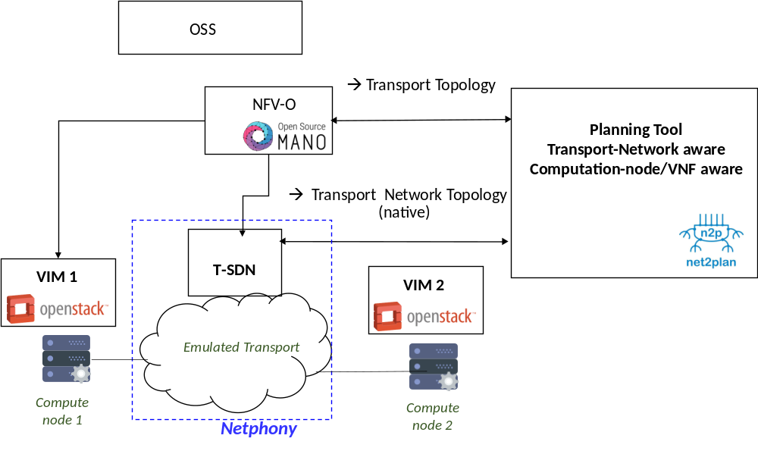
2. Innovation
Network Virtualization Functions management jointly with planning tools providing an efficient approach when using NFV service-chain-based user demands.
An Innovation section describing the problem and novelty of the approach in solving it
3. Relevance
An OFC relevance section explaining why OFC audience and communities should be interested in this demo
References
References should appear at the end of the paper in the order in which they are referenced in the body of the paper. The font should be 8 point, and the references should be aligned left.
Within the main text, references should be designated by a number in brackets [1], and they should be followed by a comma or period [2]. Two references cited at once should be included together [3,4], separated by a comma, while three or more consecutive references should be indicated by the bounding numbers and a dash [1–4].

[1] Y. Li and M. Chen, “Software-Defined Network Function Virtualization: A Survey,” in IEEE Access vol. 3 pp. 2542-2553, 2015
[2] Open Source Mano. [Online]. Avalilable: https://osm.etsi.org/
[3] Pavon-Marino et al., “Net2Plan: An Open Source Network Planning Tool for Bridging the Gap between Academia and Industry”, IEEE
Networks, September-October 2015.

[4] Author(s), "Title of paper," in Title of Proceeding, (Institute of Electrical and Electronics Engineers, New York, 1900), pp. 00-00.

[5] Author(s), "Title of paper," in Title of Proceedings, Name(s), ed(s)., Vol. XX of OSA Proceedings Series (Optical Society of America, Washington, D.C., 1900), pp. 00-00.

